MONODB QUERIES DAY 1 TASK.

1.FIND ALL INFO ABOUT EACH PRODUCTS

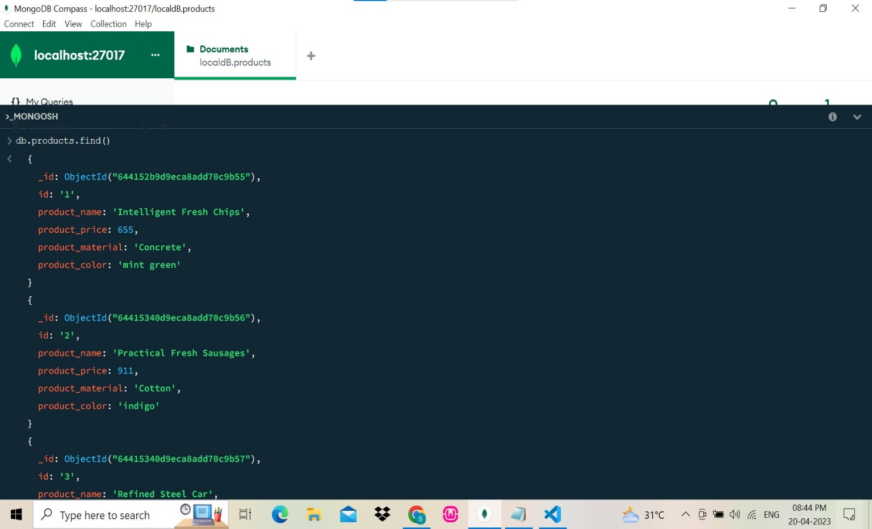

2.FIND PRODUCT PRICE BETWEEN 400-800

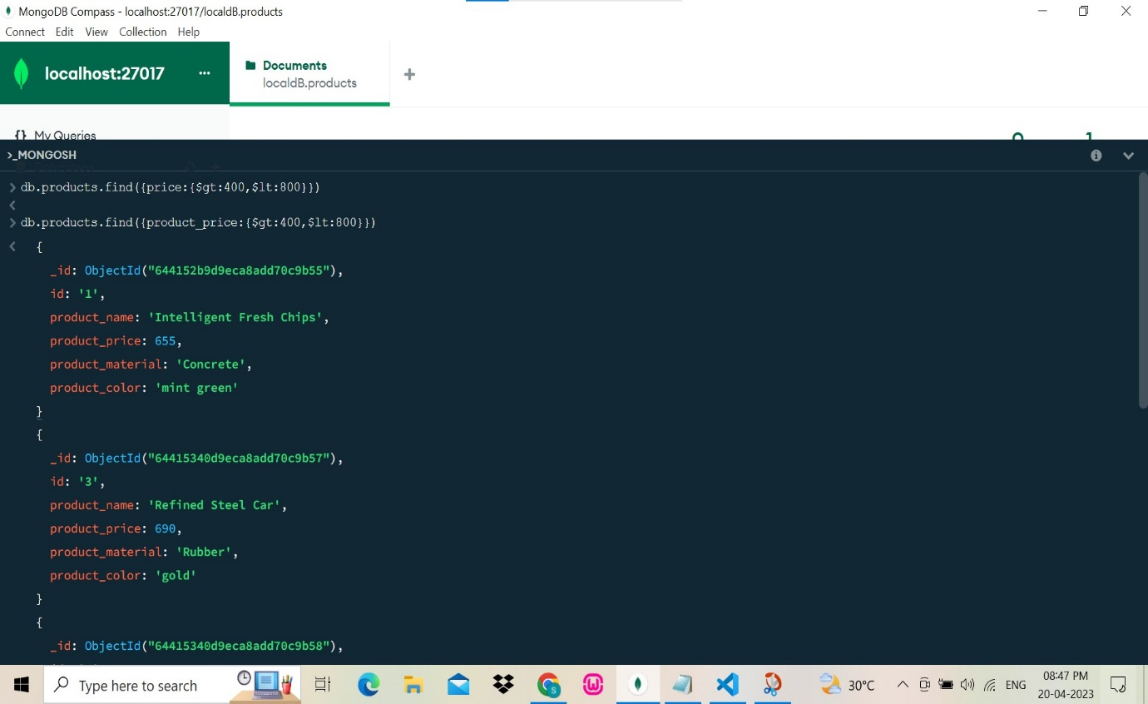

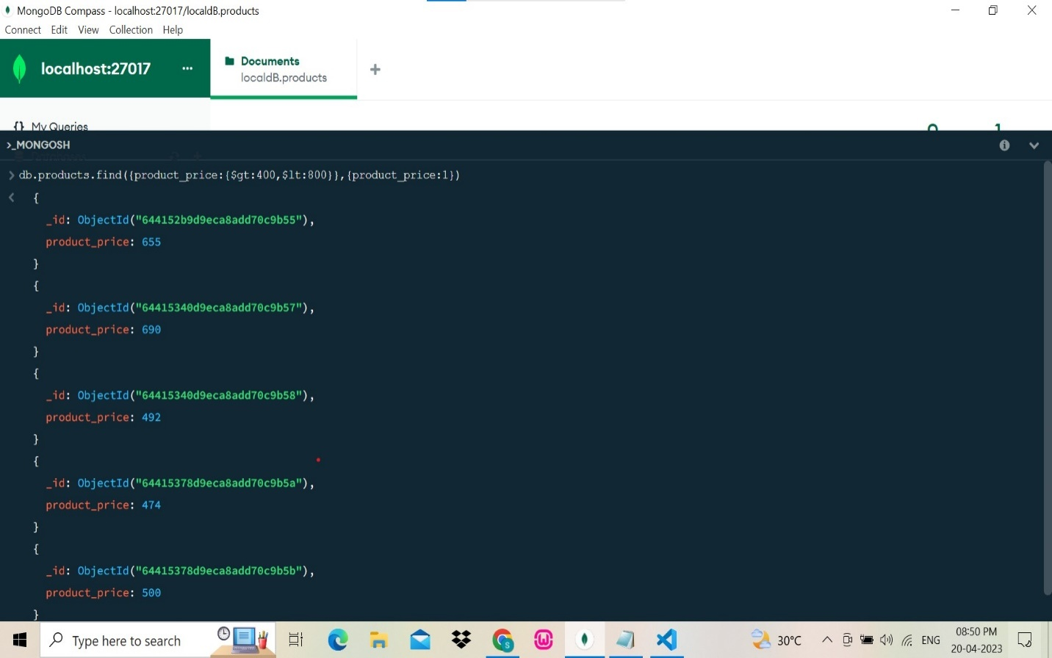

3.FIND PRODUCT PRICE NOT BETWEEN 400-600

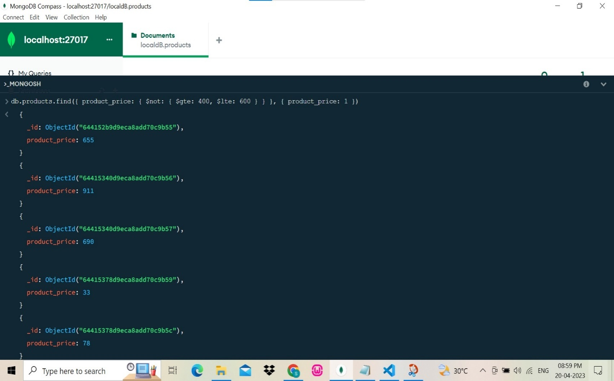

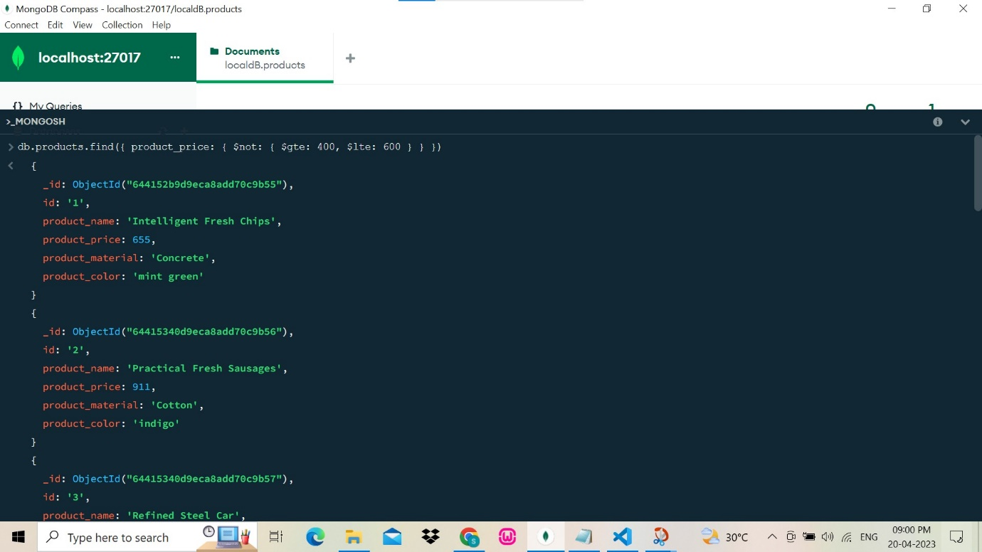

4.LIST 4 PRODUCT PRICE GREATER THAN 500

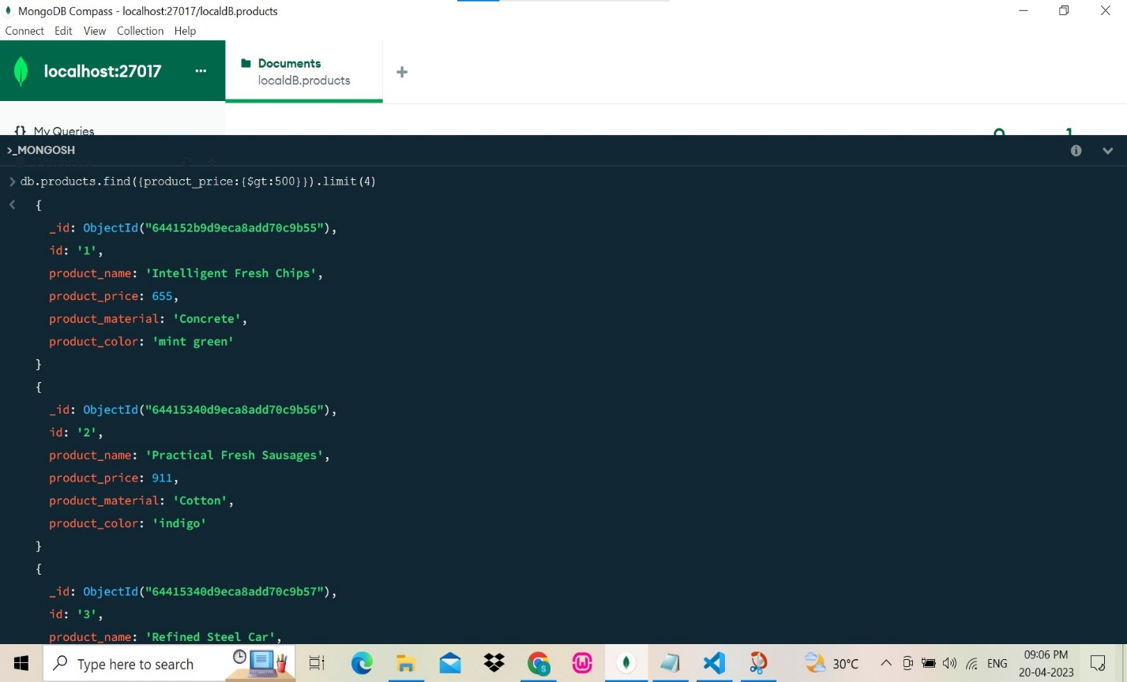

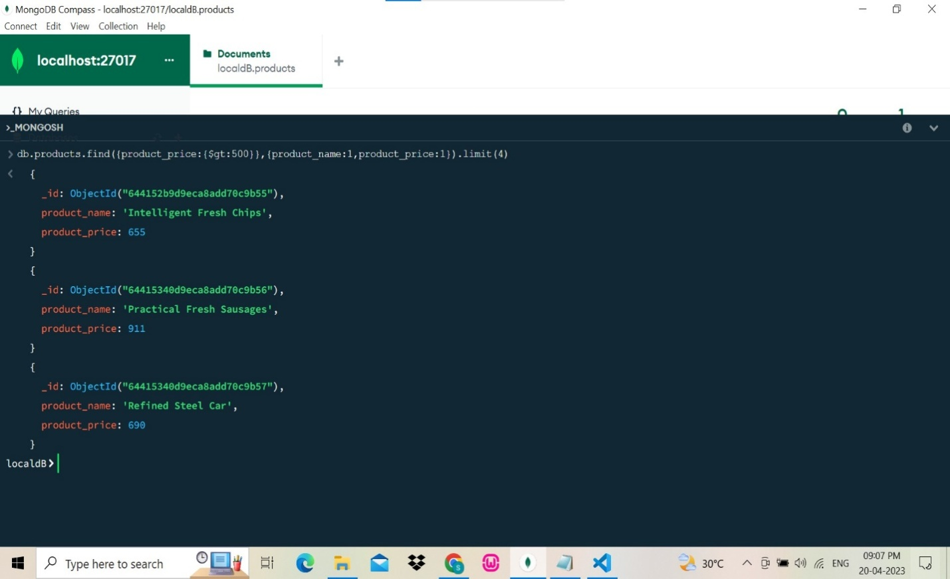

5.FIND PRODUCT NAME AND MATERIAL

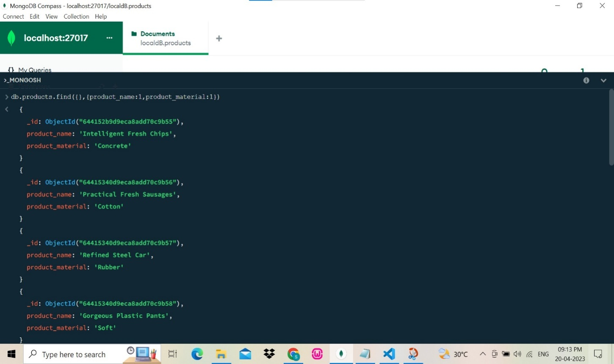

6.FIND PRODUCT WITH ID 10

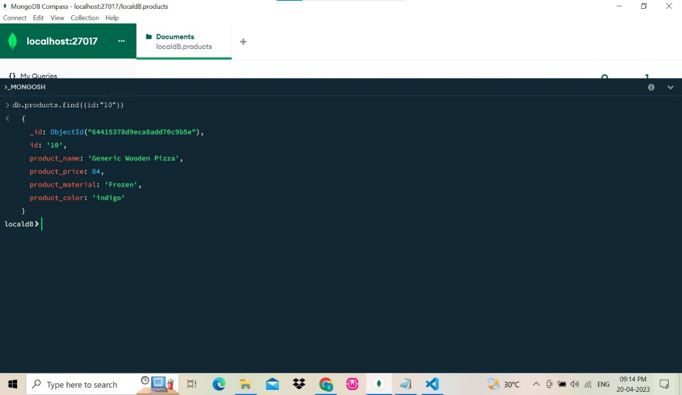

7.FIND PRODUCTS WITH MATERIAL SOFT

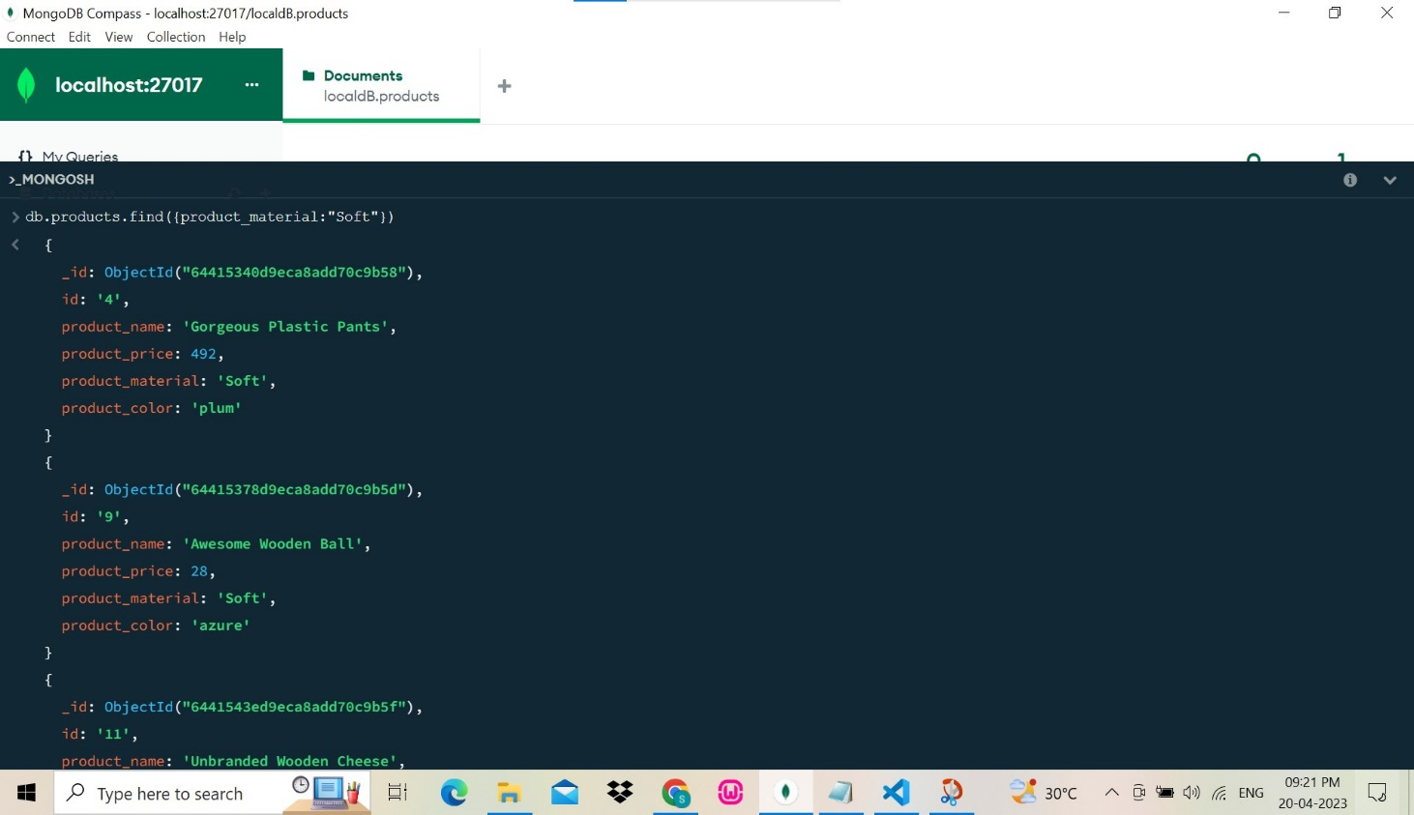

8.FIND PRODUCTS WITH COLOR INDIGO AND PRICE 492

